EMPLOYEE PAYROLL SYSTEM
Algorithm and Flowchart Documentation

1. ALGORITHM DESCRIPTION
The Employee Payroll System follows a systematic approach to process employee compensation with multiple decision points based on employee classification and eligibility criteria.

1.1 High-Level Algorithm
- START: Initialize payroll processing system
- INPUT: Collect employee data
- Employee Name, ID
- Employee Type (Full-Time, Part-Time, Contractor)
- Base Salary or Hourly Rate
- Hours Worked (if applicable)
- Overtime Hours (if applicable)
- CLASSIFY: Determine employee type
- IF employee is Full-Time THEN
- Calculate monthly salary = Annual Salary / 12
- Calculate hourly rate = Annual Salary / (52 × 40)
- ELSE IF employee is Part-Time THEN
- Use hourly rate directly
- ELSE IF employee is Contractor THEN
- Use contract hourly rate
- CALCULATE OVERTIME: Determine overtime compensation
- IF overtime hours > 0 AND employee is eligible THEN
- Overtime Pay = Overtime Hours × Hourly Rate × 1.5
- ELSE
- Overtime Pay = 0
- COMPUTE GROSS PAY
Gross Pay = Base Pay + Overtime Pay
- CALCULATE TAX: Apply progressive tax brackets
- IF Gross Pay ≤ $10,000 THEN Tax = Gross Pay × 0.10
- ELSE IF Gross Pay ≤ $40,000 THEN Tax = $1,000 + (Gross Pay - $10,000) × 0.15
- ELSE IF Gross Pay ≤ $85,000 THEN Tax = $5,500 + (Gross Pay - $40,000) × 0.22
- ELSE Tax = $15,400 + (Gross Pay - $85,000) × 0.28
- EVALUATE BENEFITS ELIGIBILITY
- IF employee is eligible for benefits THEN
- Deduct Health Insurance premium
- Calculate 401(k) contribution = Gross Pay × 0.06
- Total Benefits = Health Insurance + 401(k)
- ELSE
- Benefits Deduction = 0
- COMPUTE NET PAY
Net Pay = Gross Pay - Tax - Benefits Deductions
- GENERATE REPORT: Display payroll statement with all details
- CHECK: Are there more employees to process?
- IF yes THEN GOTO Step 2 (process next employee)
- ELSE continue to Step 10
- DISPLAY: Generate comprehensive payroll summary
- Total number of employees processed
- Total gross payroll
- Total net payroll
- Total deductions
- END: Payroll processing complete

1.2 Pseudocode
ALGORITHM: EmployeePayrollSystem
BEGIN
Initialize PayrollManager
Initialize EmployeeList
FOR each employee IN EmployeeList DO
// Step 1: Determine employee type and base calculation
SWITCH (employee.type)
CASE "FullTime":
monthlySalary ← employee.annualSalary / 12
hourlyRate ← employee.annualSalary / (52 × 40)
basePay ← monthlySalary
CASE "PartTime":
hourlyRate ← employee.hourlyRate
IF hoursWorked ≤ 160 THEN
basePay ← hoursWorked × hourlyRate
ELSE
basePay ← 160 × hourlyRate
END IF
CASE "Contractor":
basePay ← employee.hoursWorked × employee.contractRate
END SWITCH
// Step 2: Calculate overtime
IF employee.overtimeHours > 0 AND employee.eligibleForOvertime THEN
overtimePay ← employee.overtimeHours × hourlyRate × 1.5
ELSE
overtimePay ← 0
END IF
// Step 3: Calculate gross pay
grossPay ← basePay + overtimePay
// Step 4: Calculate tax using progressive brackets
IF grossPay ≤ 10000 THEN
tax ← grossPay × 0.10
ELSE IF grossPay ≤ 40000 THEN
tax ← 1000 + (grossPay - 10000) × 0.15
ELSE IF grossPay ≤ 85000 THEN
tax ← 5500 + (grossPay - 40000) × 0.22
ELSE
tax ← 15400 + (grossPay - 85000) × 0.28
END IF
// Step 5: Calculate benefits deductions
IF employee.type ≠ "Contractor" THEN
healthInsurance ← employee.healthInsurancePremium
retirement401k ← grossPay × 0.06
benefitsDeduction ← healthInsurance + retirement401k
ELSE
benefitsDeduction ← 0
tax ← tax + (grossPay × 0.153) // Add self-employment tax
END IF
// Step 6: Calculate net pay
netPay ← grossPay - tax - benefitsDeduction
// Step 7: Generate employee payroll statement
DISPLAY PayrollStatement(employee, grossPay, tax, benefitsDeduction, netPay)
// Step 8: Update totals
totalGrossPay ← totalGrossPay + grossPay
totalNetPay ← totalNetPay + netPay
totalDeductions ← totalDeductions + (tax + benefitsDeduction)
END FOR
// Step 9: Display summary
DISPLAY "Total Employees: " + employeeCount
DISPLAY "Total Gross Payroll: $" + totalGrossPay
DISPLAY "Total Net Payroll: $" + totalNetPay
DISPLAY "Total Deductions: $" + totalDeductions
END

2. SYSTEM FLOWCHART
The following flowchart provides a visual representation of the payroll processing algorithm, illustrating the decision points, process flows, and data operations involved in calculating employee compensation.
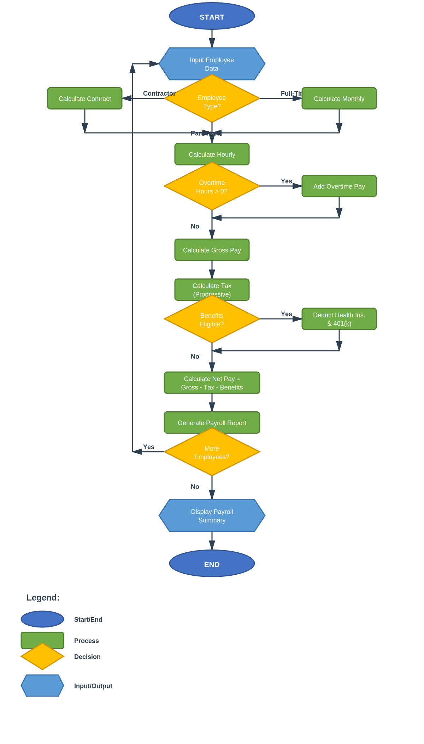

3. COMPLEXITY ANALYSIS

3.1 Time Complexity
Time Complexity: O(n), where n is the number of employees
The algorithm processes each employee exactly once through a single iteration. All calculations for each employee (gross pay, tax, benefits, net pay) are performed in constant time O(1). Therefore, the overall time complexity is linear with respect to the number of employees.

3.2 Space Complexity
Space Complexity: O(n), where n is the number of employees
The system stores employee objects in a collection (vector), requiring linear space proportional to the number of employees. Additional space is used for intermediate calculations, but this is constant per employee.

4. ALGORITHM CHARACTERISTICS

4.1 Decision Points
The algorithm contains three primary decision points:
1. Employee Type Classification: Determines the calculation method for base pay
2. Overtime Eligibility: Checks if overtime compensation should be applied
3. Benefits Eligibility: Determines which deductions apply to the employee

4.2 Data Flow
The system follows a unidirectional data flow pattern:
Input → Classification → Base Calculation → Overtime → Gross Pay → Tax Calculation → Benefits Deduction → Net Pay → Output
This sequential processing ensures accurate calculations with no circular dependencies.

4.3 Scalability
The algorithm is designed for scalability:
• Linear time complexity allows efficient processing of large employee databases
• Modular design enables easy addition of new employee types
• Object-oriented architecture supports extension without modification
• Polymorphic behavior allows uniform handling of different employee categories

Employee Payroll System - Algorithm & Flowchart Documentation

